1.Query: Audience Distribution by Gender and Age Group
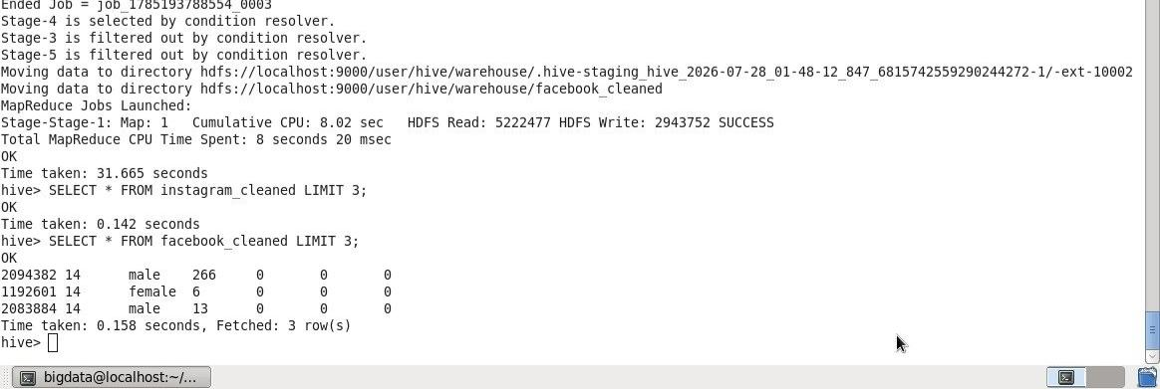
2.
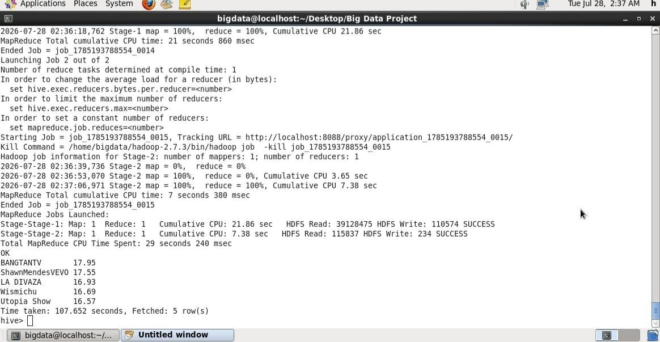

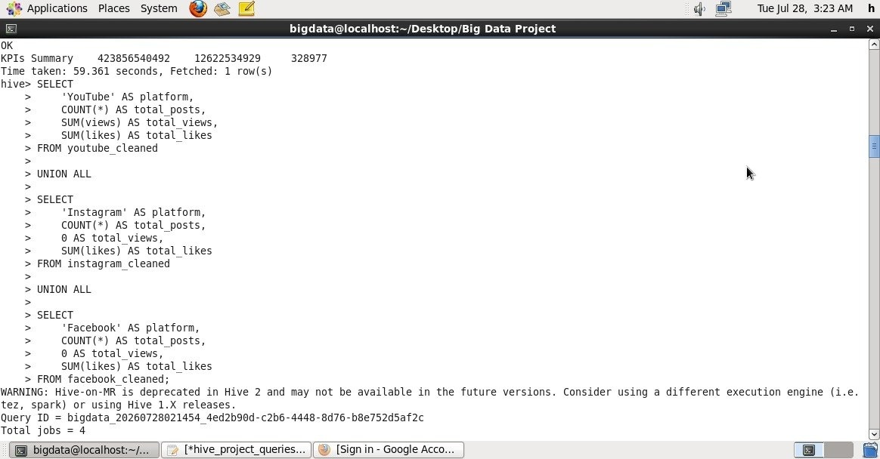
3.Query: Total Views and Likes by Social Media Platform

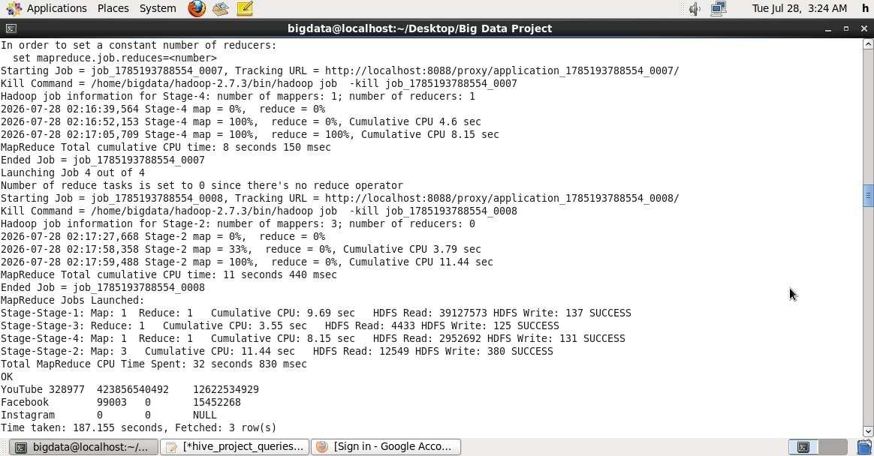

4.Query: Total Shares by Account Type
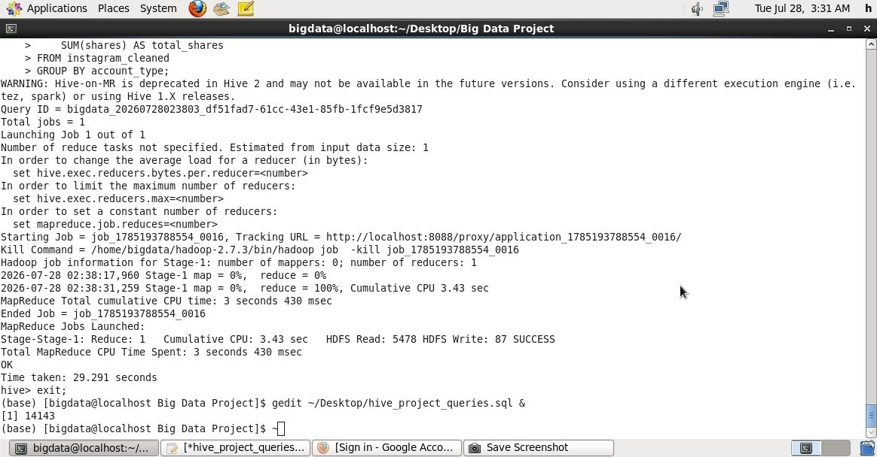

5.Query: Previewing Cleaned Data for Instagram and Facebook
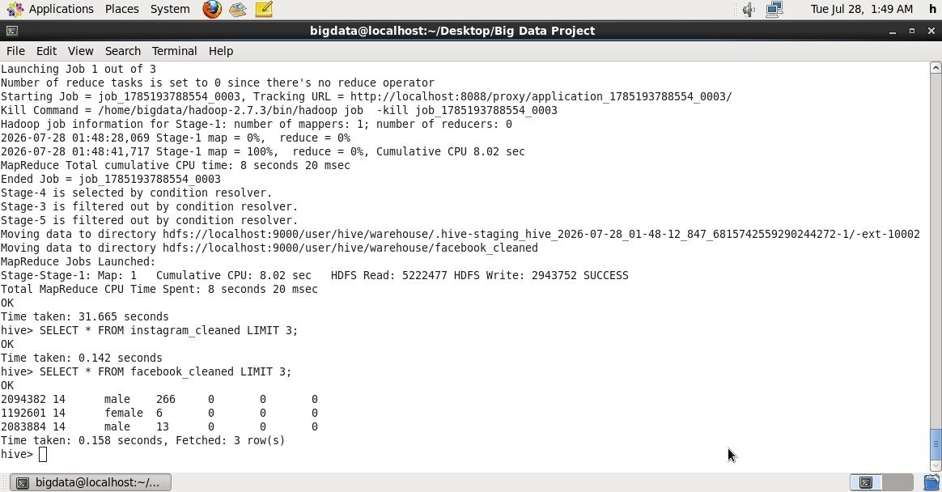
6.Query: Top 5 YouTube Channels by Engagement
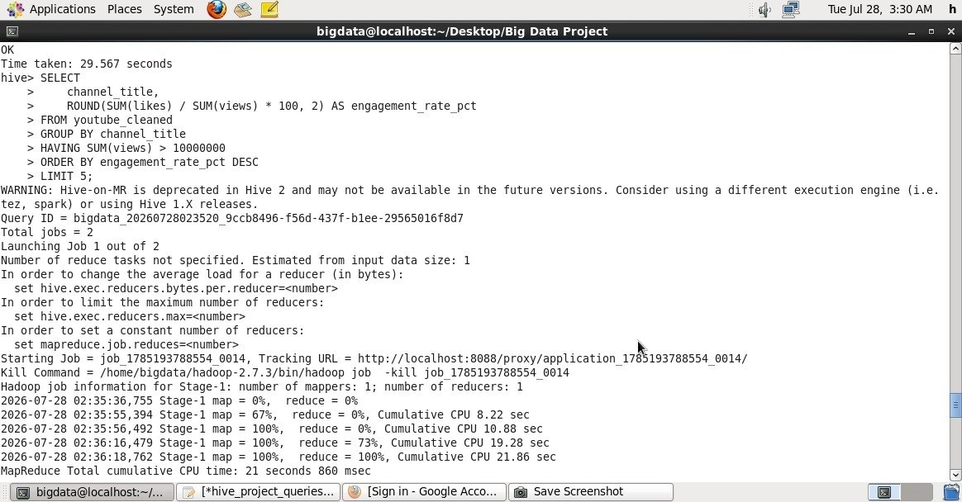

7.Audience Distribution by Gender and Age Group
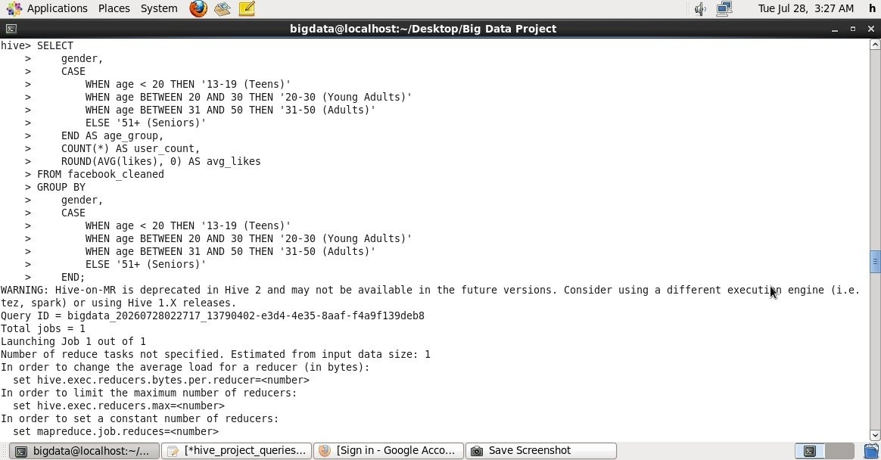

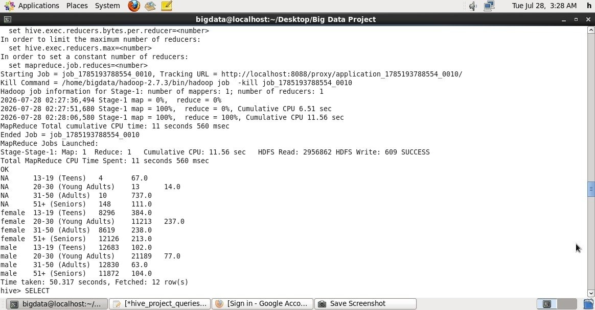
8. Top 10 YouTube Channels by Total Views and Likes
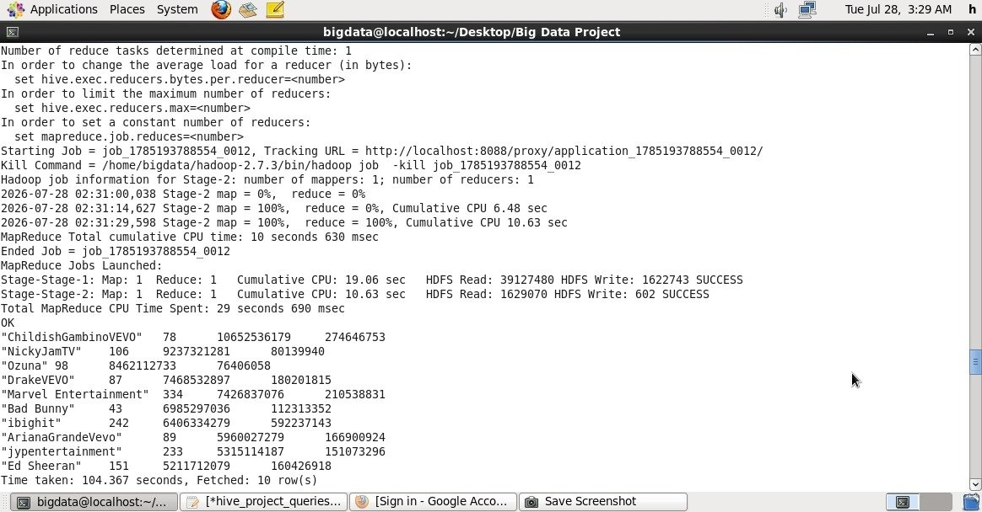
9.YouTube KPIs Summary (Total Views, Likes, and Videos)
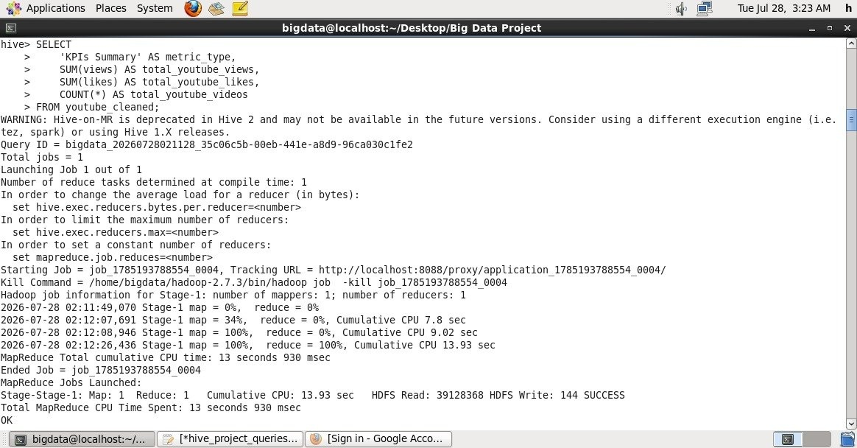

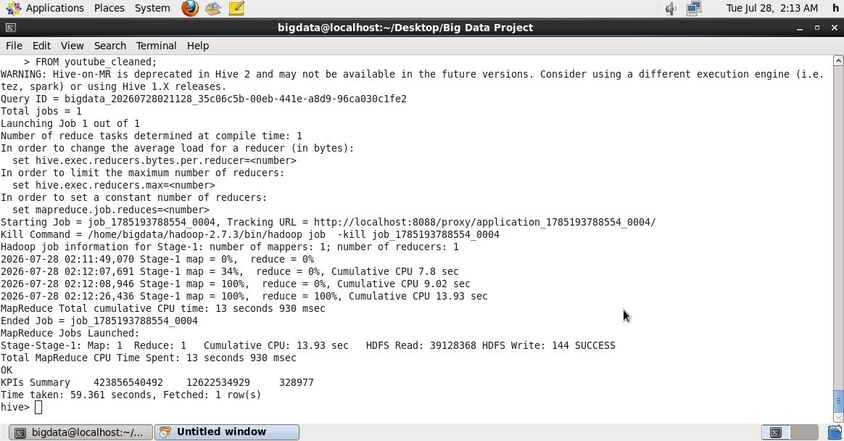

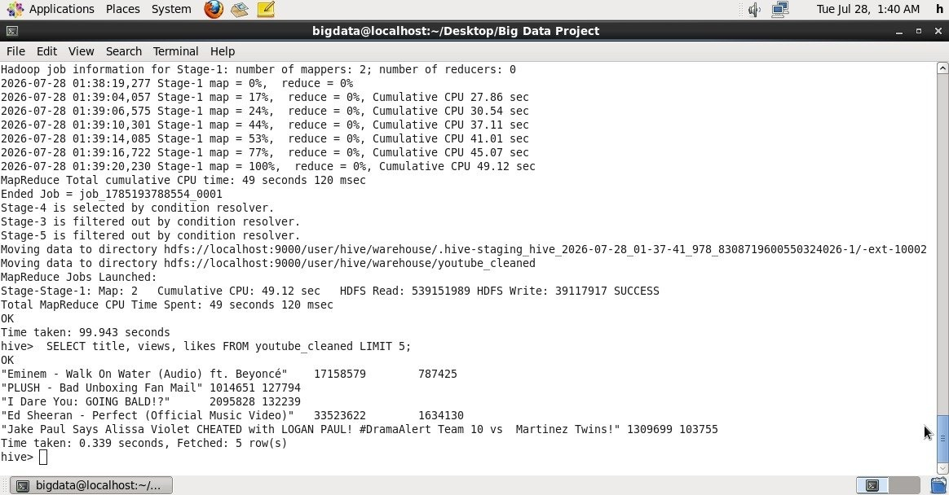
10. Previewing Cleaned Data for YouTube

11.Instagram Engagement by Account Type and Media Type
